TechTrunk Ventures Pvt. Ltd

A

Project Report

On

“Controlling a robot by using raspberry pi and MQTT protocol from two platforms:

* From AWS platform
* From mobile using NODE-RED Starter”

For the Course

“Internet Of Things (IoT)”

**SUBMITTED BY:**

Voonna Sivani

V Pawan Kumar Senapati

**GUIDED BY:**

Mr. Aashish Pandey

***ABSTRACT***

Internet of Things (IoT) is an innovation that interfaces all things and the Internet in shrewd spaces. By executions of knowledge with detecting gadgets, IoT has been broadly connected to various fields, for example, savvy homes, the application fields in keen homes consolidate brilliance into home territories for comfort, wellbeing, security, medicinal services, and vitality protection.

Here we will be able to control a robot with any mobile device or other device from any corner of the world where there is an access to internet.

The user will publish the command to the robot either from AWS platform or from mobile device. According to the corresponding condition the following GPIO pin(s) will be either set to HIGH or LOW which leads to the movement of the robot is the particular direction.

The same method can be used to control any electrical appliances from any part of the world if the corresponding device is connected to internet.

***INTRODUCTION***

**Internet of Things (IoT)** is the networking of physical objects that contain electronics embedded within their architecture in order to communicate and sense interactions amongst each other or with respect to the external environment. In the upcoming years, IoT-based technology will offer advanced levels of services and practically change the way people lead their daily lives. Advancements in medicine, power, gene therapies, agriculture, smart cities, and smart homes are just a very few of the categorical examples where IoT is strongly established.

Basically, **IoT is a network in which all physical objects are connected to the internet** through network devices or routers and exchange data. IoT allows objects to be controlled remotely across existing network infrastructure. IoT is a very good and intelligent technique which reduces human effort as well as easy access to physical devices. This technique also has autonomous control feature by which any device can control without any human interaction.

**Modern Applications:**

1. Smart Grids
2. Smart cities
3. Smart homes
4. Healthcare
5. Earthquake detection
6. Radiation detection/hazardous gas detection
7. Smartphone detection
8. Water flow monitoring
9. Automated Vehicles

***COMPONENTS REQUIRED***

1. Raspberry pi 3
2. L239D motor driver
3. Toy motors
4. Wheels and castor wheel
5. Jumper (female-female)

***COMPONENTS DESCRIPTION***

**1.Raspberry pi 3:**

The [**Raspberry Pi 3**](https://www.raspberrypi.org/blog/raspberry-pi-3-on-sale/) is here! Hopefully some of you were still surprised by the announcement today. Over the past four years, the Raspberry Pi has sold eight million units – three million in the last year alone – and now on its fourth birthday a brand new upgraded Pi has been released. You can read absolutely everything you’d want to know about it in issue 43 of the magazine coming out on Thursday but for now we thought we’d give you the hard facts about this brand new Raspberry Pi.

**Raspberry Pi 3 Specifications**

**SoC:** Broadcom BCM2837  
**CPU:** 4× ARM Cortex-A53, 1.2GHz  
**GPU:** Broadcom VideoCore IV  
**RAM:** 1GB LPDDR2 (900 MHz)  
**Networking:** 10/100 Ethernet, 2.4GHz 802.11n wireless  
**Bluetooth:** Bluetooth 4.1 Classic, Bluetooth Low Energy  
**Storage:** microSD  
**GPIO:** 40-pin header, populated  
**Ports:** HDMI, 3.5mm analogue audio-video jack, 4× USB 2.0, Ethernet, Camera Serial Interface (CSI), Display Serial Interface (DSI)

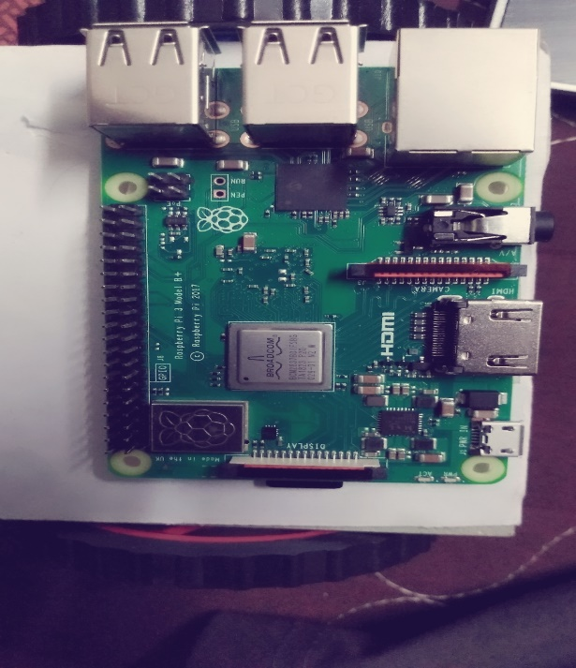

**2.L239D Motor Driver:**

L293D is a typical Motor driver or Motor Driver IC which allows DC motor to drive on either direction. L293D is a 16-pin IC which can control a set of two DC motors simultaneously in any direction. It means that you can control two [DC motor](https://www.rakeshmondal.info/High-Torque-Motor-Low-RPM-Motor) with a single L293D IC. Dual H-bridge Motor Driver integrated circuit*(*IC*).*The l293d can drive small and quiet big motors as well, check the Voltage Specification at the end of this page for more info.

You can Buy L293D IC in any electronic shop very easily and it costs around 70 Rupees (INR) (approx Cost) or even lesser cost.

Concept

It works on the concept of H-bridge. H-bridge is a circuit which allows the voltage to be flown in either direction. As you know voltage need to change its direction for being able to rotate the motor in clockwise or anticlockwise direction, Hence H-bridge IC are ideal for driving a DC motor.In a single L293D chip there are two h-Bridge circuit inside the IC which can rotate two dc motor independently. Due its size it is very much used in robotic application for controlling DC motors. Given below is the pin diagram of a L293D motor controller.

There are two Enable pins on l293d. Pin 1 and pin 9, for being able to drive the motor, the pin 1 and 9 need to be high. For driving the motor with left H-bridge you need to enable pin 1 to high. And for right H-Bridge you need to make the pin 9 to high. If anyone of the either pin1 or pin9 goes low then the motor in the corresponding section will suspend working. It’s like a switch.

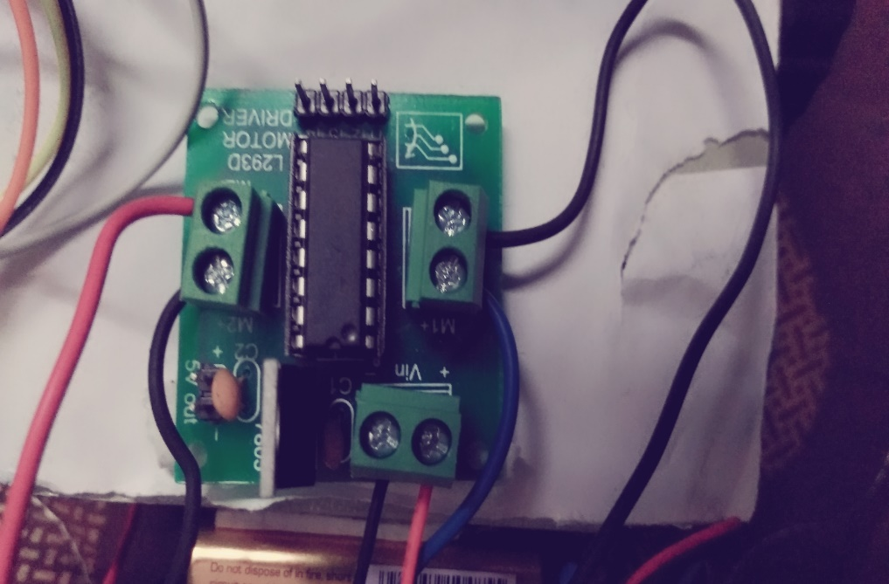

**3. Toy Motors:**

These are very basic motors, and have no built-in encoders, speed control or positional feedback. Voltage goes in, rotation goes out! There will be variation from motor to motor, so a separate feedback system is required if you need precision movement.

You can power these motors with 3VDC up to 6VDC, they'll of course go a little faster at the higher voltages. We grabbed one motor and found these stats when running it from a bench-top supply

* At 3VDC we measured 150mA @ 120 RPM no-load, and 1.1 Amps when stalled
* At 4.5VDC we measured 155mA @ 185 RPM no-load, and 1.2 Amps when stalled
* At 6VDC we measured 160mA @ 250 RPM no-load, and 1.5 Amps when stalled.

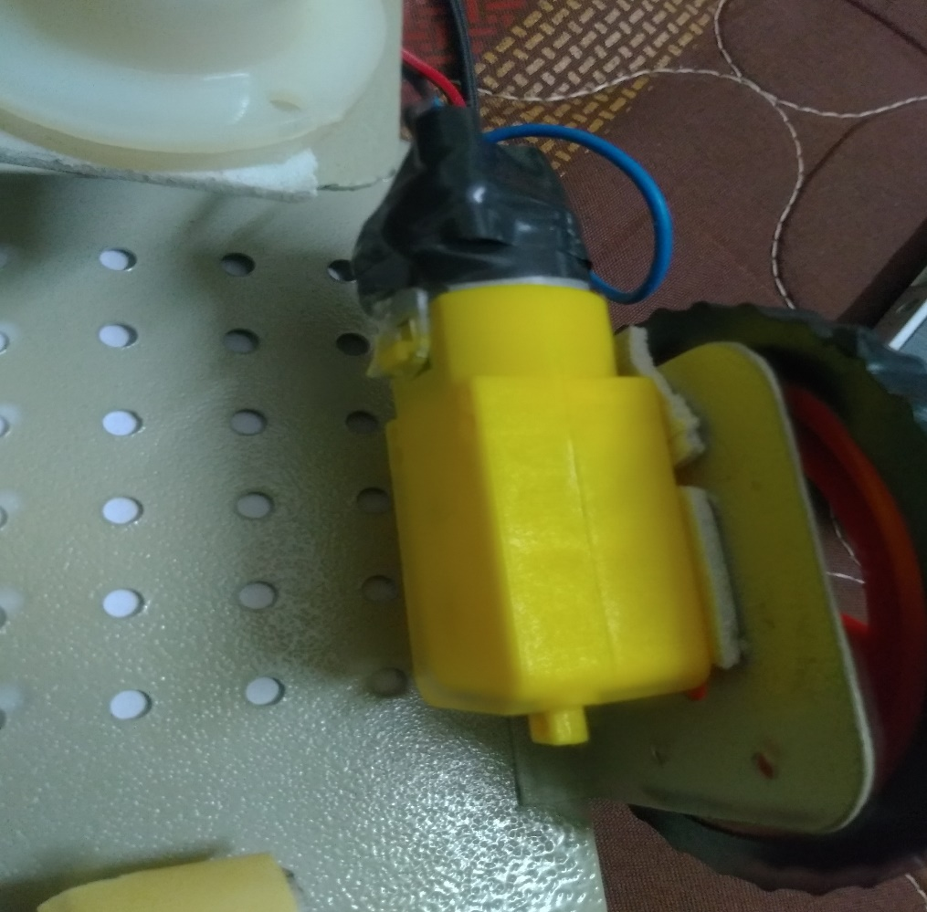

**4. Wheels and Castor wheel:**

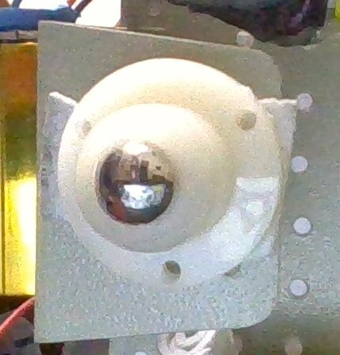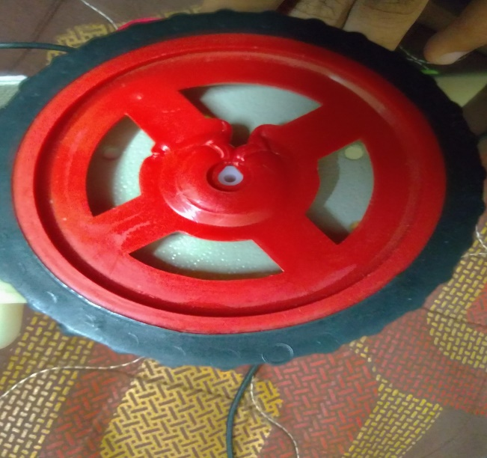

**4. Jumper wires (female-female):**

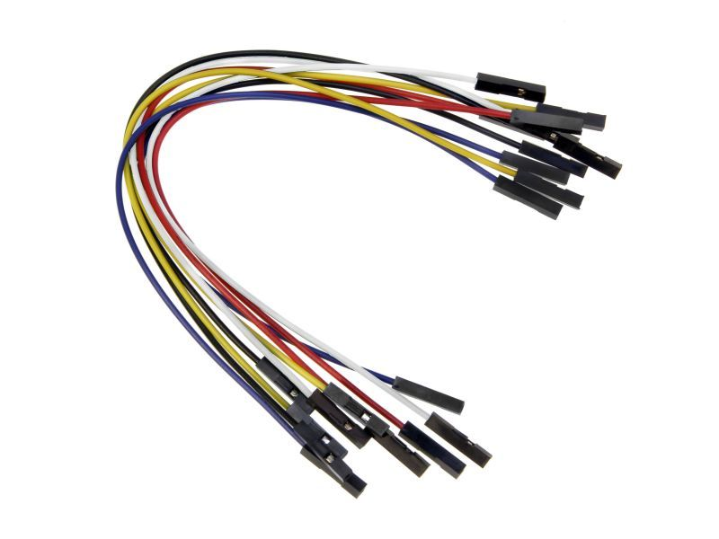

***AWS IOT***

**AWS IoT** (Amazon internet of things) is an Amazon Web Services platform that collects and analyzes data from internet-connected devices and sensors and connects that data to **AWS** cloud applications

It enables you to connect devices to AWS Services and other devices, secure data and interactions, process and act upon device data, and enable applications to interact with devices even when they are offline.

**Architecture of AWS IOT:**

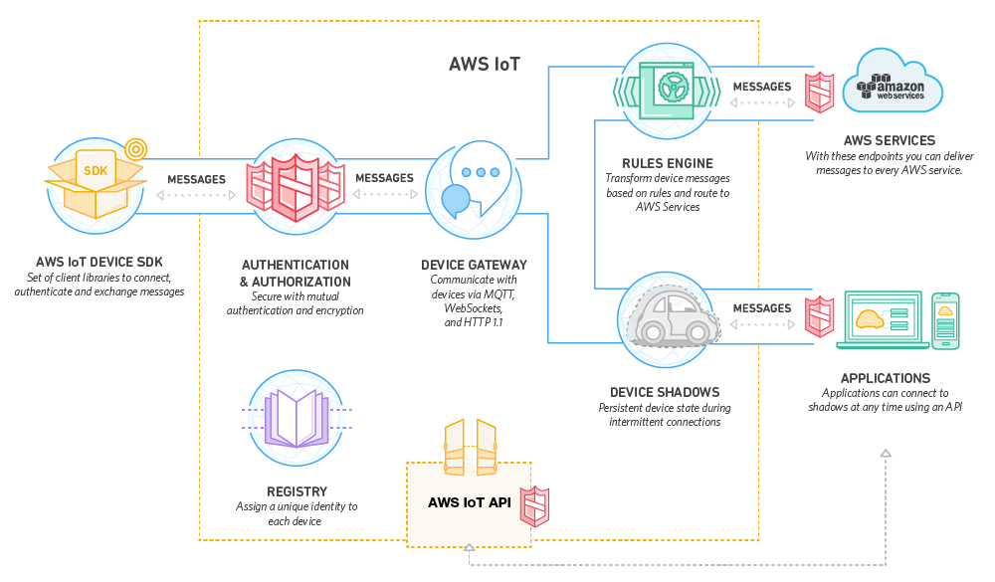AWS IoT Device SDK :

AWS IoT provides an SDK(Software Development Kit) to help you easily and quickly connect your hardware device or your mobile application. The AWS IoT Device SDK enables your devices to connect, authenticate, and exchange messages with AWS IoT using the MQTT, HTTP or Web Sockets protocols.

Device Gateway:

The AWS IoT Device Gateway enables devices to securely and efficiently communicate with AWS IoT. The Device Gateway can exchange messages using a publication/subscription model, which enables one-to-one and one-to-many communications. With this one-to-many communication pattern AWS IoT makes it possible for a connected device to publish data to multiple subscribers for a given topic.

## Authentication and Authorization:

AWS IoT provides mutual authentication and encryption at all points of connection, so that data is never exchanged between devices and AWS IoT without proven identity. AWS IoT supports the AWS method of authentication (called ‘SigV4’) as well as X.509 certificate based authentication. Connections using HTTP can use either of these methods, while connections using MQTT use certificate based authentication, and connections using WebSockets can use SigV4.

Registry:

The Registry establishes an identity for devices and tracks metadata such as the devices’ attributes and capabilities. The Registry assigns a unique identity to each device that is consistently formatted regardless of the type of device or how it connects. It also supports metadata that describes the capabilities of a device, for example whether a sensor reports temperature, and if the data are Fahrenheit or Celsius.

Device Shadows:

With AWS IoT you can create a persistent, virtual version, or “shadow,” of each device that includes the device’s latest state so that applications or other devices can read messages and interact with the device. The Device Shadows persist the last reported state and desired future state of each device even when the device is offline. You can retrieve the last reported state of a device or set a desired future state through the API or using the rules engine.

Device Shadows let you store the state of your devices for up to a year for free. Device Shadows persist forever if you update them at least once per year, otherwise they expire.

Rules Engine:

The Rules Engine makes it possible to build IoT applications that gather, process, analyze and act on data generated by connected devices at global scale without having to manage any infrastructure. The Rules Engine evaluates inbound messages published into AWS IoT and transforms and delivers them to another device or a cloud service, based on business rules you define. A rule can apply to data from one or many devices, and it can take one or many actions in parallel.

**Why AWS IOT?**

* It’s Easy to Start With AWS IoT
* High IoT Security Standards
* AWS Cherishes Its Start-up Community and Cultivates start up Culture
* Serverless Architecture is the Right Choice for Start-ups
* Powerful AWS IoT Analytics Paired With AI and Machine Learning

***NODE-RED***

Node-Red in its simplest form is an [open source](https://www.peerlyst.com/tags/open-source) visual editor for wiring the [internet of things](https://www.peerlyst.com/tags/internet-of-things) produced by IBM. Node-RED is a flow-based development tool for visual programming developed originally by IBM for wiring together hardware devices, APIs and online services as part of the Internet of Things. Node-RED provides a web browser-based flow editor, which can be used to create JavaScript functions.

Node-RED as its name reflects was developed using [Node.js](https://www.peerlyst.com/tags/node-js) [framework](https://www.peerlyst.com/tags/framework) to bring out a light-weight and browser oriented user interface. It comes with a highly inoperable design which allows it to link both physical and digital type of things together.

The system contains “Nodes” which look simply to be icons that you drag and drop on to the canvas and [wire](https://www.peerlyst.com/tags/wire) together. Each Node offers different functionality which can range from a simple debug node to be able to see what’s going on in your flow, through to a [Raspberry Pi](https://www.peerlyst.com/tags/raspberry-pi) node which allows you to read and write to the GPIO pins of your Pi.

***CODE***

1. **Python code to control the bot from AWS platform:**

import paho.mqtt.client as s

import ssl

import RPi.GPIO as p

p.setmode(p.BOARD)

p.setwarnings(False)

p.setup(3,p.OUT)

p.setup(5,p.OUT)

p.setup(7,p.OUT)

p.setup(11,p.OUT)

ca=r"/home/pi/spproject/certificate1/AmazonRootCA1.pem.txt"

cer=r"/home/pi/spproject/certificate1/f162b5c987-certificate.pem.crt"

key=r"/home/pi/spproject/certificate1/f162b5c987-private.pem.key"

def abc(c,u,msg):

if msg.payload.decode()=="forward":

p.output(3,0)

p.output(5,1)

p.output(7,0)

p.output(11,1)

if msg.payload.decode()=="backward":

p.output(3,1)

p.output(5,0)

p.output(7,1)

p.output(11,0)

if msg.payload.decode()=="left":

p.output(3,0)

p.output(5,0)

p.output(7,0)

p.output(11,1)

if msg.payload.decode()=="right":

p.output(3,0)

p.output(5,1)

p.output(7,0)

p.output(11,0)

if msg.payload.decode()=="stop":

p.output(3,0)

p.output(5,0)

p.output(7,0)

p.output(11,0)

c=s.Client()

c.tls_set(ca,cer,key,cert_reqs=ssl.CERT_REQUIRED,tls_version=ssl.PROTOCOL_TLSv1_2,ciphers=None)

c.connect("AWS CUSTOM END POINT",8883)

c.on_message=abc

c.subscribe("projectsample")

c.loop_forever()

NOTE: Run this python code on Raspberry pi window and then open the AWS platform and then proceed as follows:

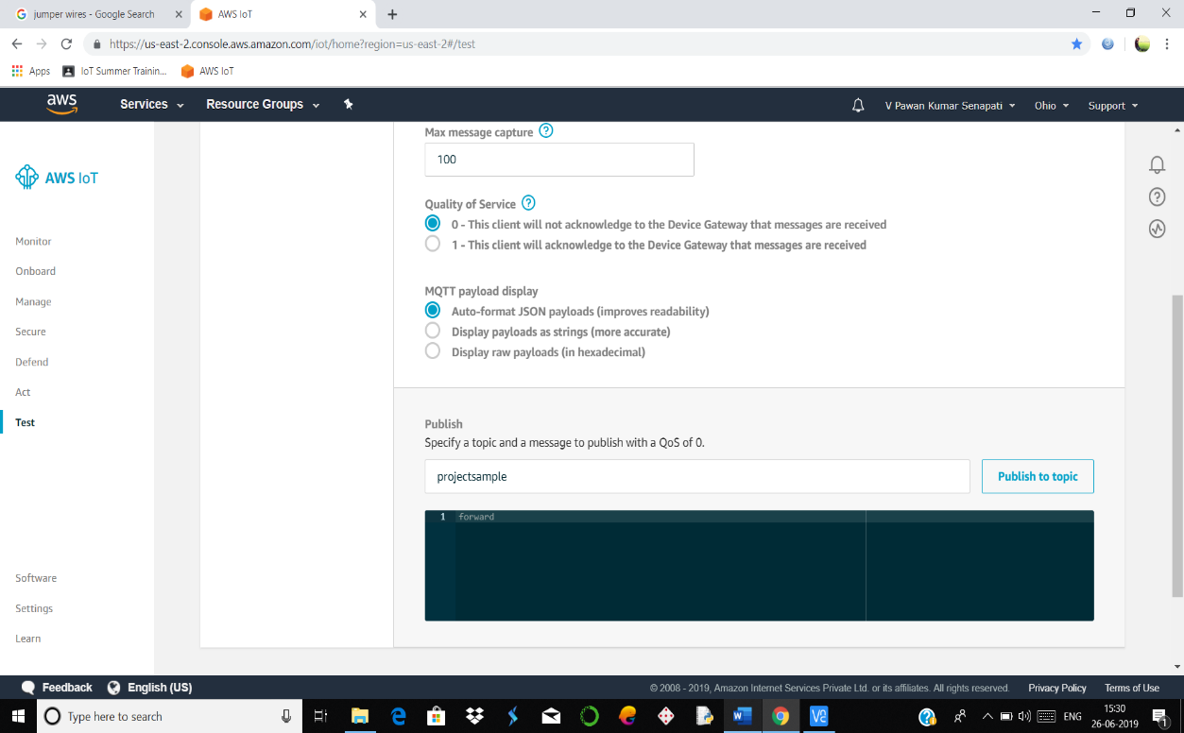

**2.From mobile device using Node-Red starter**

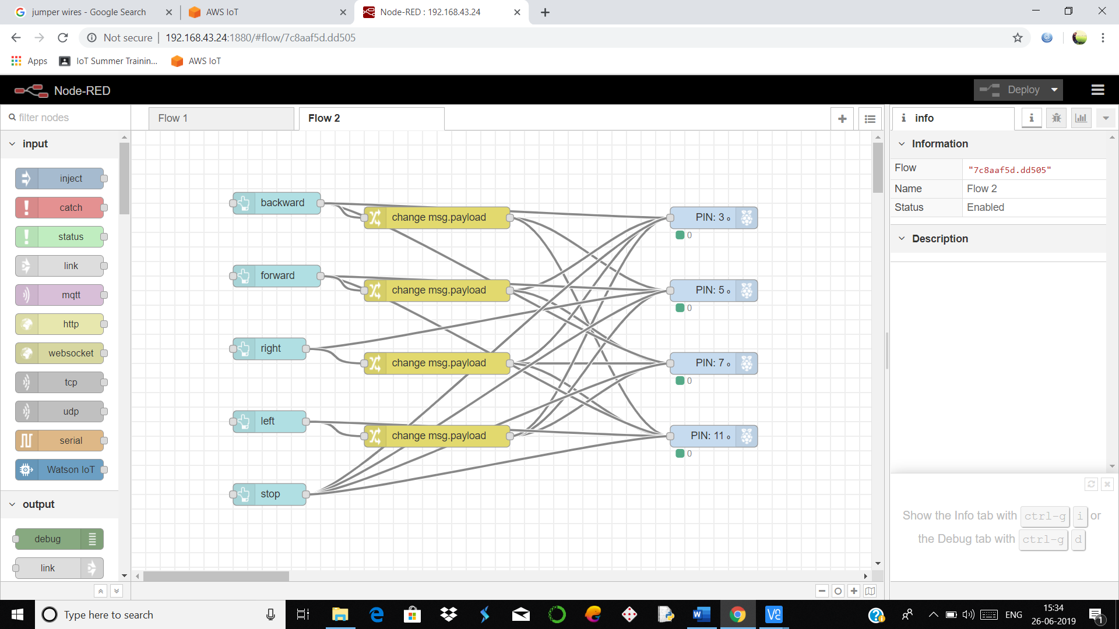

Now open the node-red user interface window in your mobile with the following url:

**https:“ your-raspberry-node-red-url ”/ui**

Then the following window will open in your mobile:

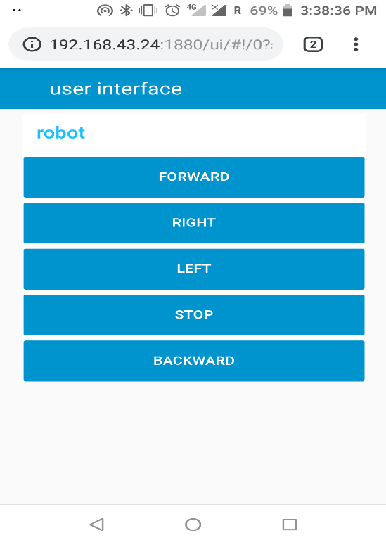

***CONCLUSION***

The IoT has the potential to dramatically increase the availability   
of information, and is likely to transform companies and organizations   
in virtually every industry around the world.   
  
As such, finding ways to leverage the power of the IoT is expected to   
factor into the strategic objectives of most technology companies,   
regardless of their industry focus.   
  
The number of different technologies required to support the   
deployment and further growth of the IoT places a premium on   
interoperability, and has resulted in widespread efforts to develop   
standards and technical specifications that support seamless   
communication between IoT devices and components. Collaboration   
between various standards development groups and consolidation   
of some current efforts will eventually result in greater clarity for IoT   
technology companies.

We hope our project will be helpful in improving the current standards of living and also can be helpful in the advancement of current technology.